**Problem Statement:**

A small company Axon, which is a retailer selling classic cars, is facing issues in managing and analyzing their sales data. The sales team is struggling to make sense of the data and they do not have a centralized system to manage and analyze the data. The management is unable to get accurate and up-to-date sales reports, which is affecting the decision-making process.

The goal of the capstone project is to design and implement a BI solution using PowerBI and SQL that can help the company manage and analyze their sales data effectively.

**DATA SET LINK:**

:<https://drive.google.com/file/d/1OB_iGw6vVS5KS7QwiwVChbeTfR4WvUy3/view?usp=share_link>

**To solve the above Problem Statement, the given steps can be followed:**

1. **Use the data source provided**: Use the MySQL database provided as a data source.
2. **Extract and clean the data:** The next step is to extract the data from the identified sources and clean it to make it ready for analysis. This may involve tasks such as removing duplicates, handling missing values, and ensuring data consistency.
3. **Load the data into a PowerBI:** The cleaned data can then be loaded into a centralized database.
4. **Design the dashboards and reports:** Using PowerBI, data can be visualized in the form of interactive dashboards and reports. These dashboards and reports can be designed to provide useful insights and information to the management.
5. **Deploy the solution:** The final step is to deploy the BI solution to the sales team and management.

**INSIGHTS FROM DASHBOARD:**

1. Total Product-line is 7.
2. Total Quantity Order By Customer is 1,05,516.
3. Total sales $96,04,251.
4. Total Quantity in stock is 5,55,131.
5. Total Price of Stock product $5,62,87,968.
6. Remaining Quantity 449615.
7. Remaining sales left is $4,66,83,717.
8. Total 27 country where products are sold.
9. Company has office in 5 different countries.
10. Classic car has highest quantity in stock.

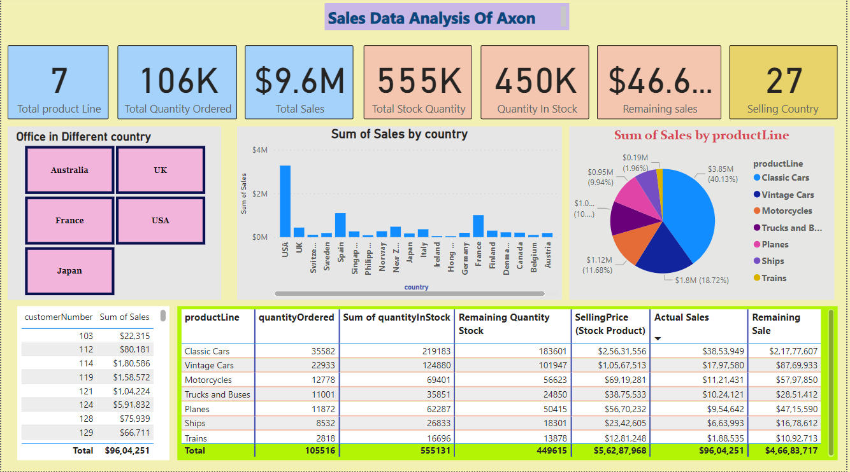 **DASHBOARD**